**Racine Kane**

**M2GL**

**Explication et details du projet JEE TP Keycloak**

Sécurité des applications avec Keycloak (Spring MVC)

Projet productapp

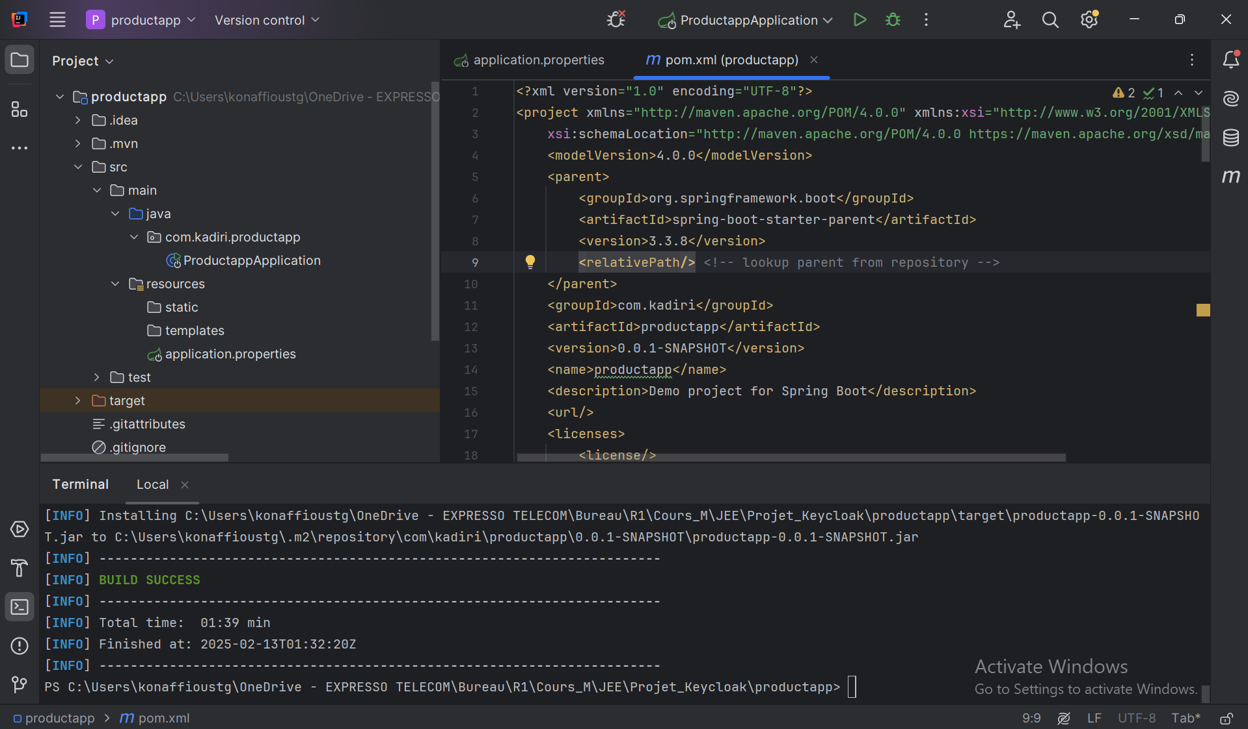

ProductController

Product

ProductRepository

ProductService

Dockerfile

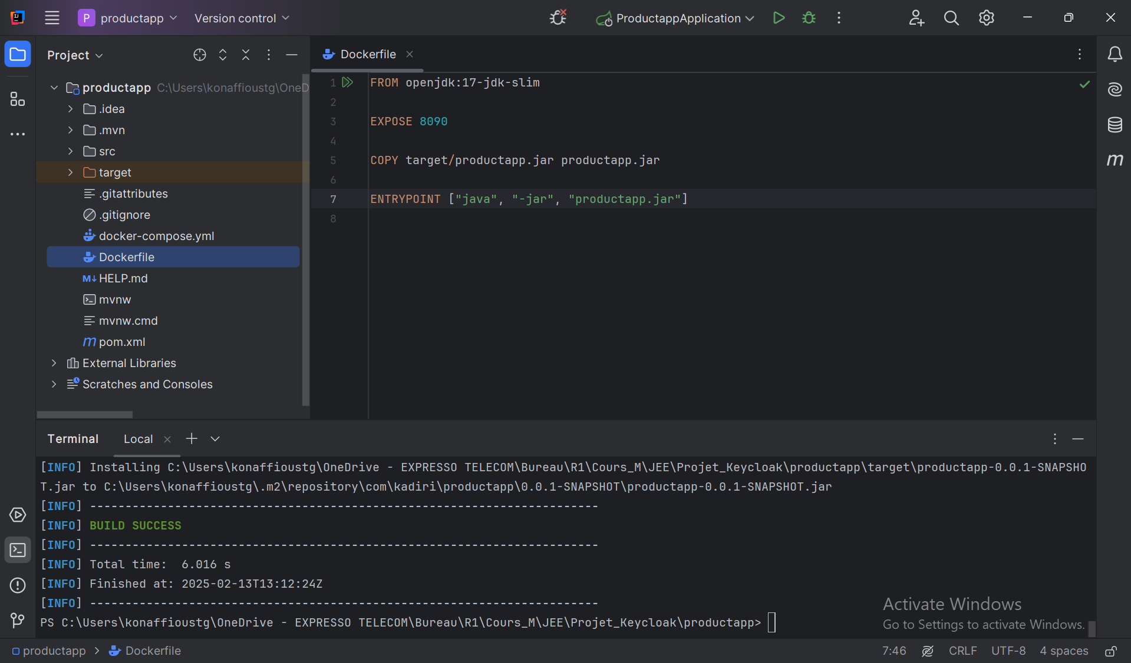

Docker-compose up -d

Démarrage du service keycloak

](http://localhost:8080/)

Puis nous pouvons cliquer sur Administration Console

Nous allons saisir : admin/password comme identifiant (ref : fichier docker-compose)

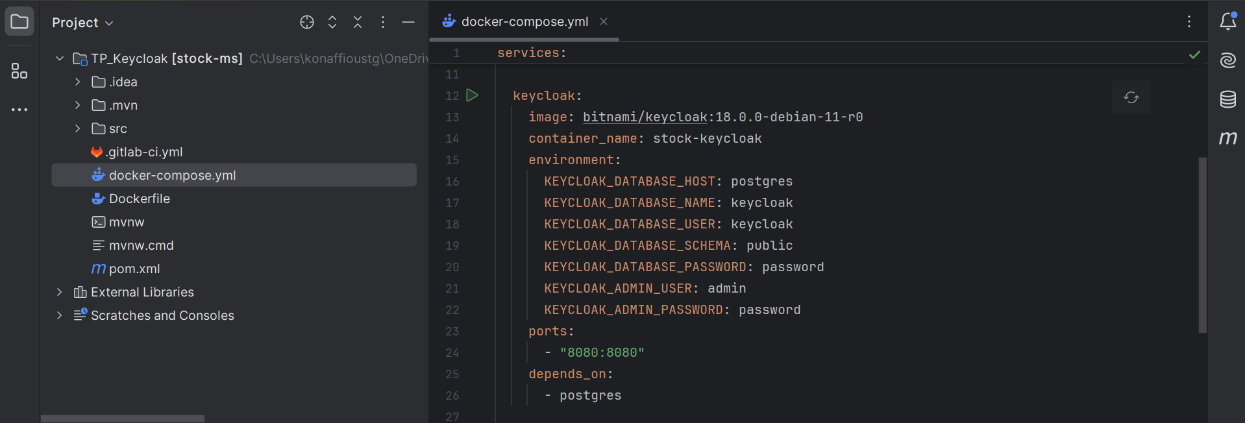

Docker

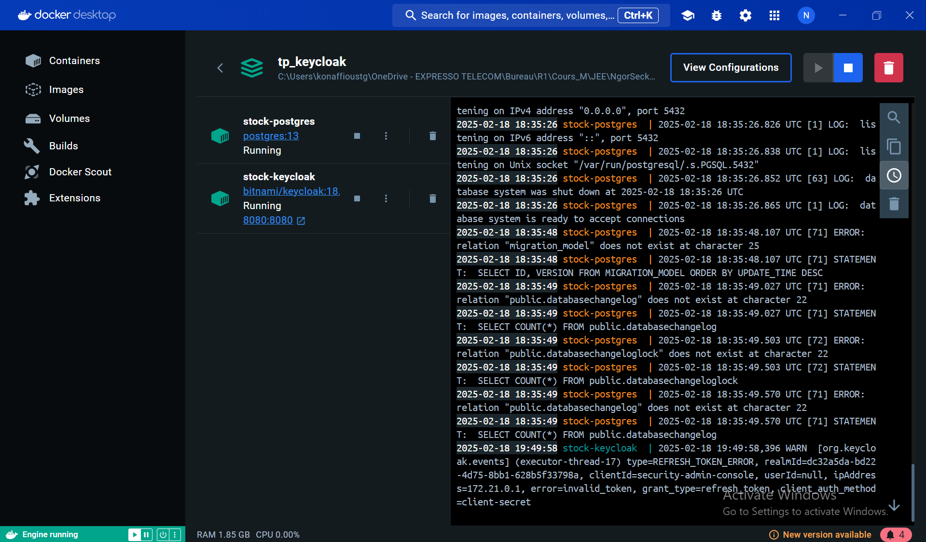

Et nous aurons cette page d’administration

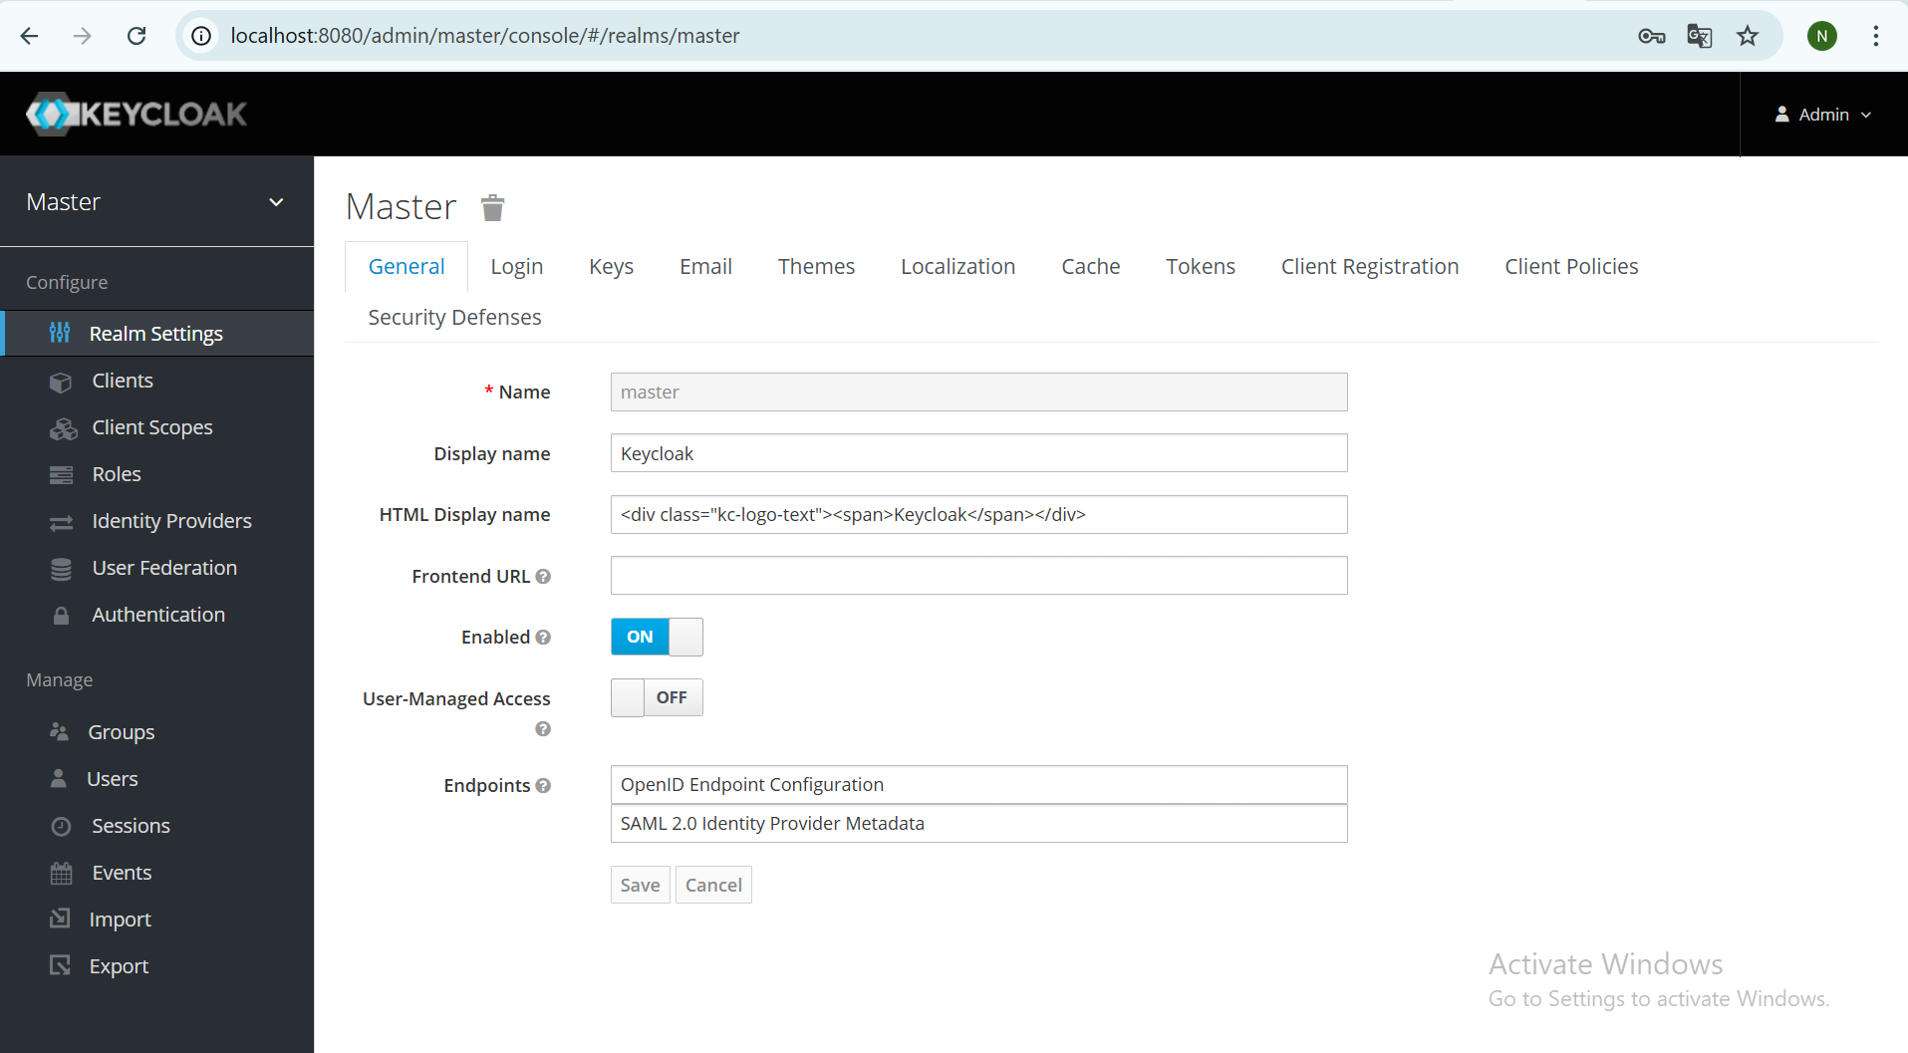

Création de realm : stock-ms

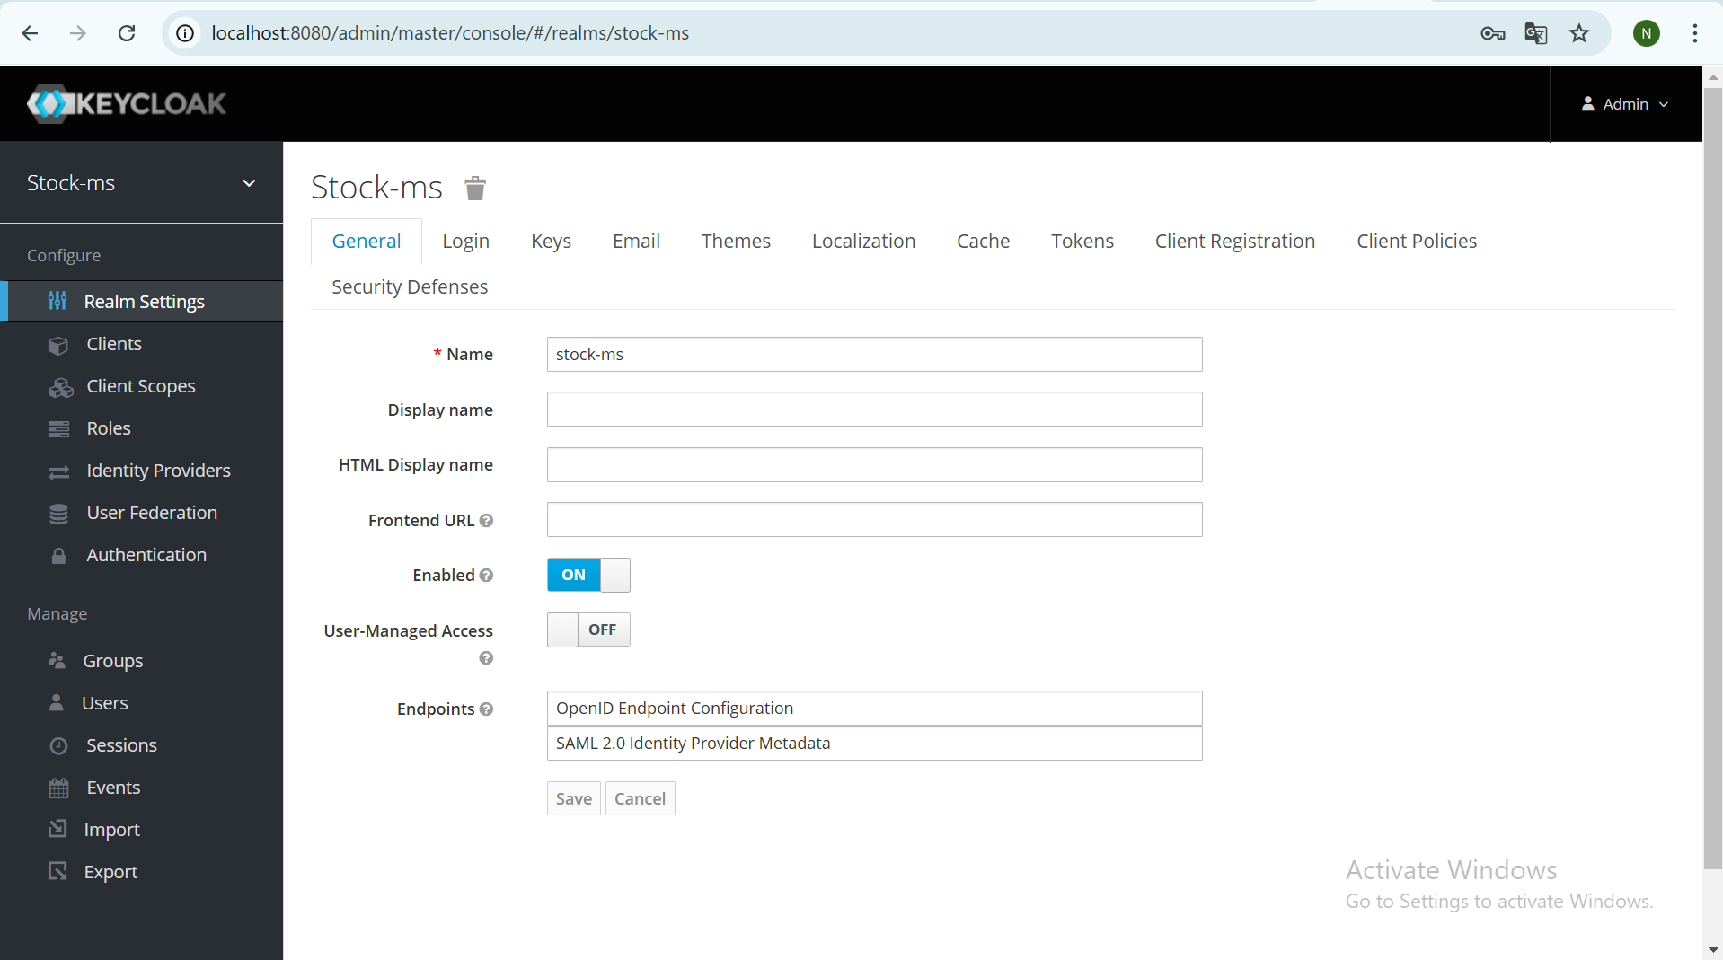

General

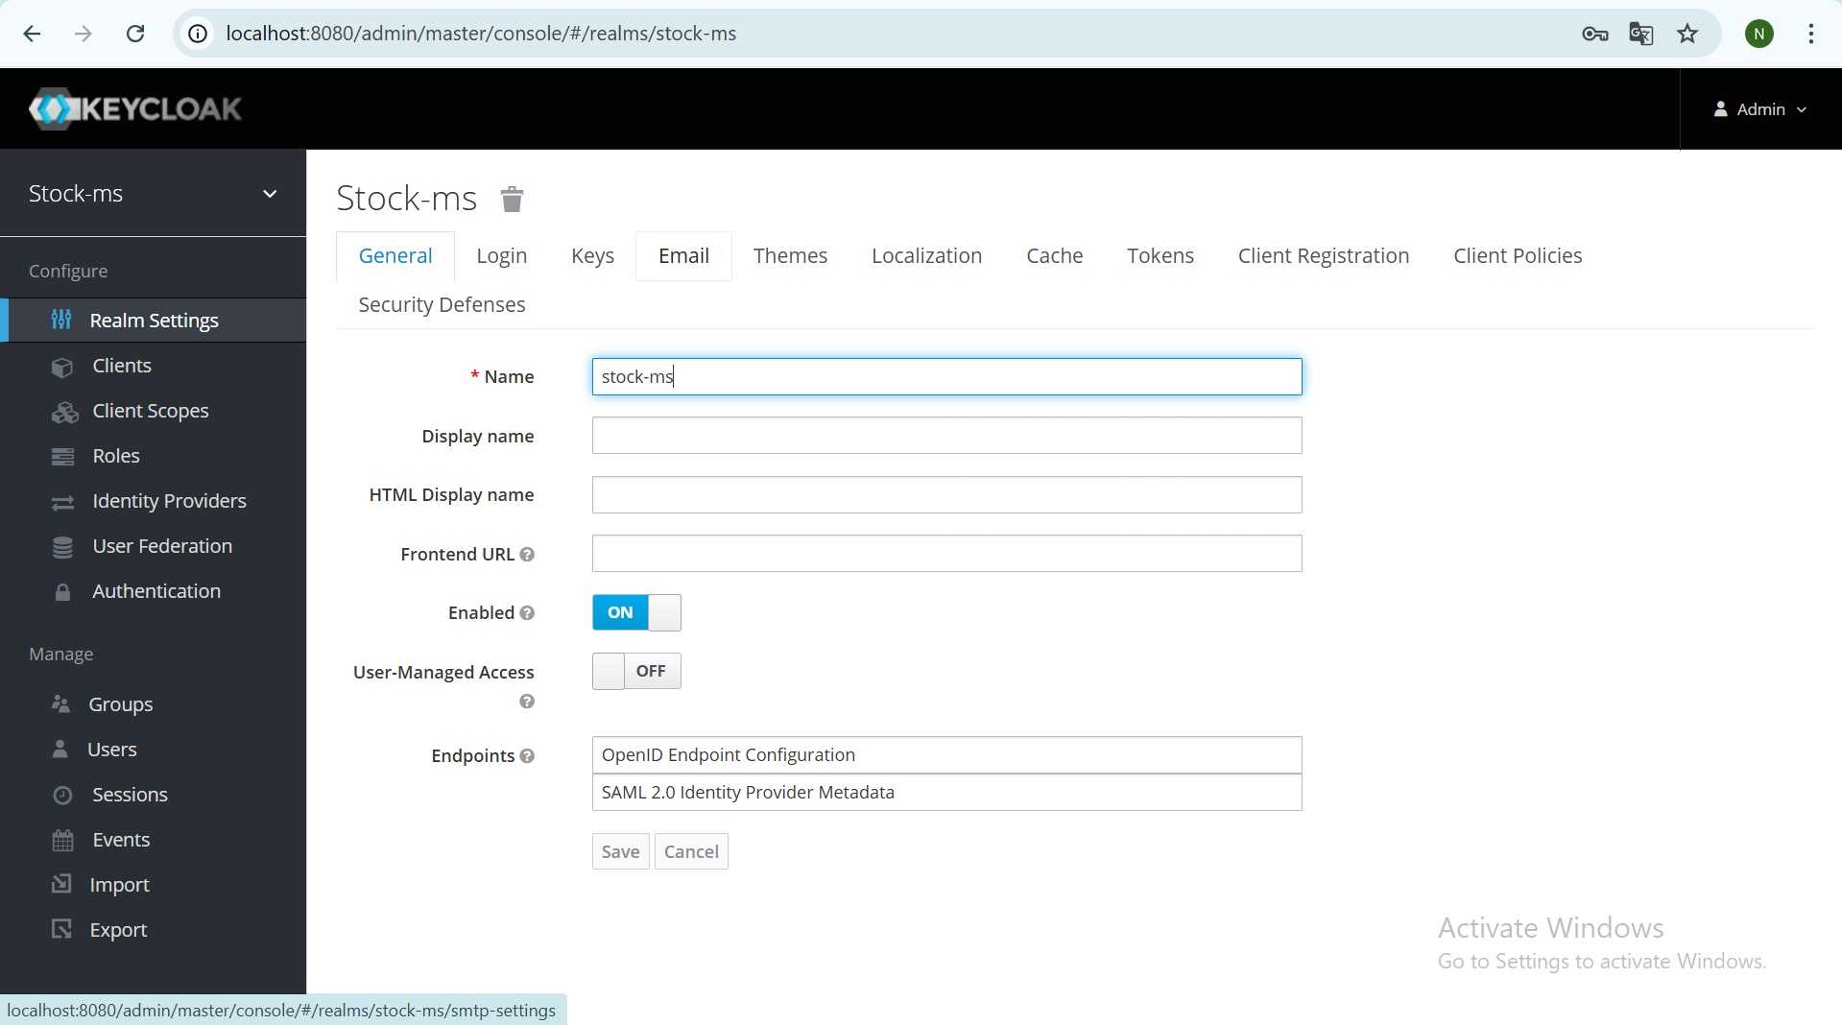

Login

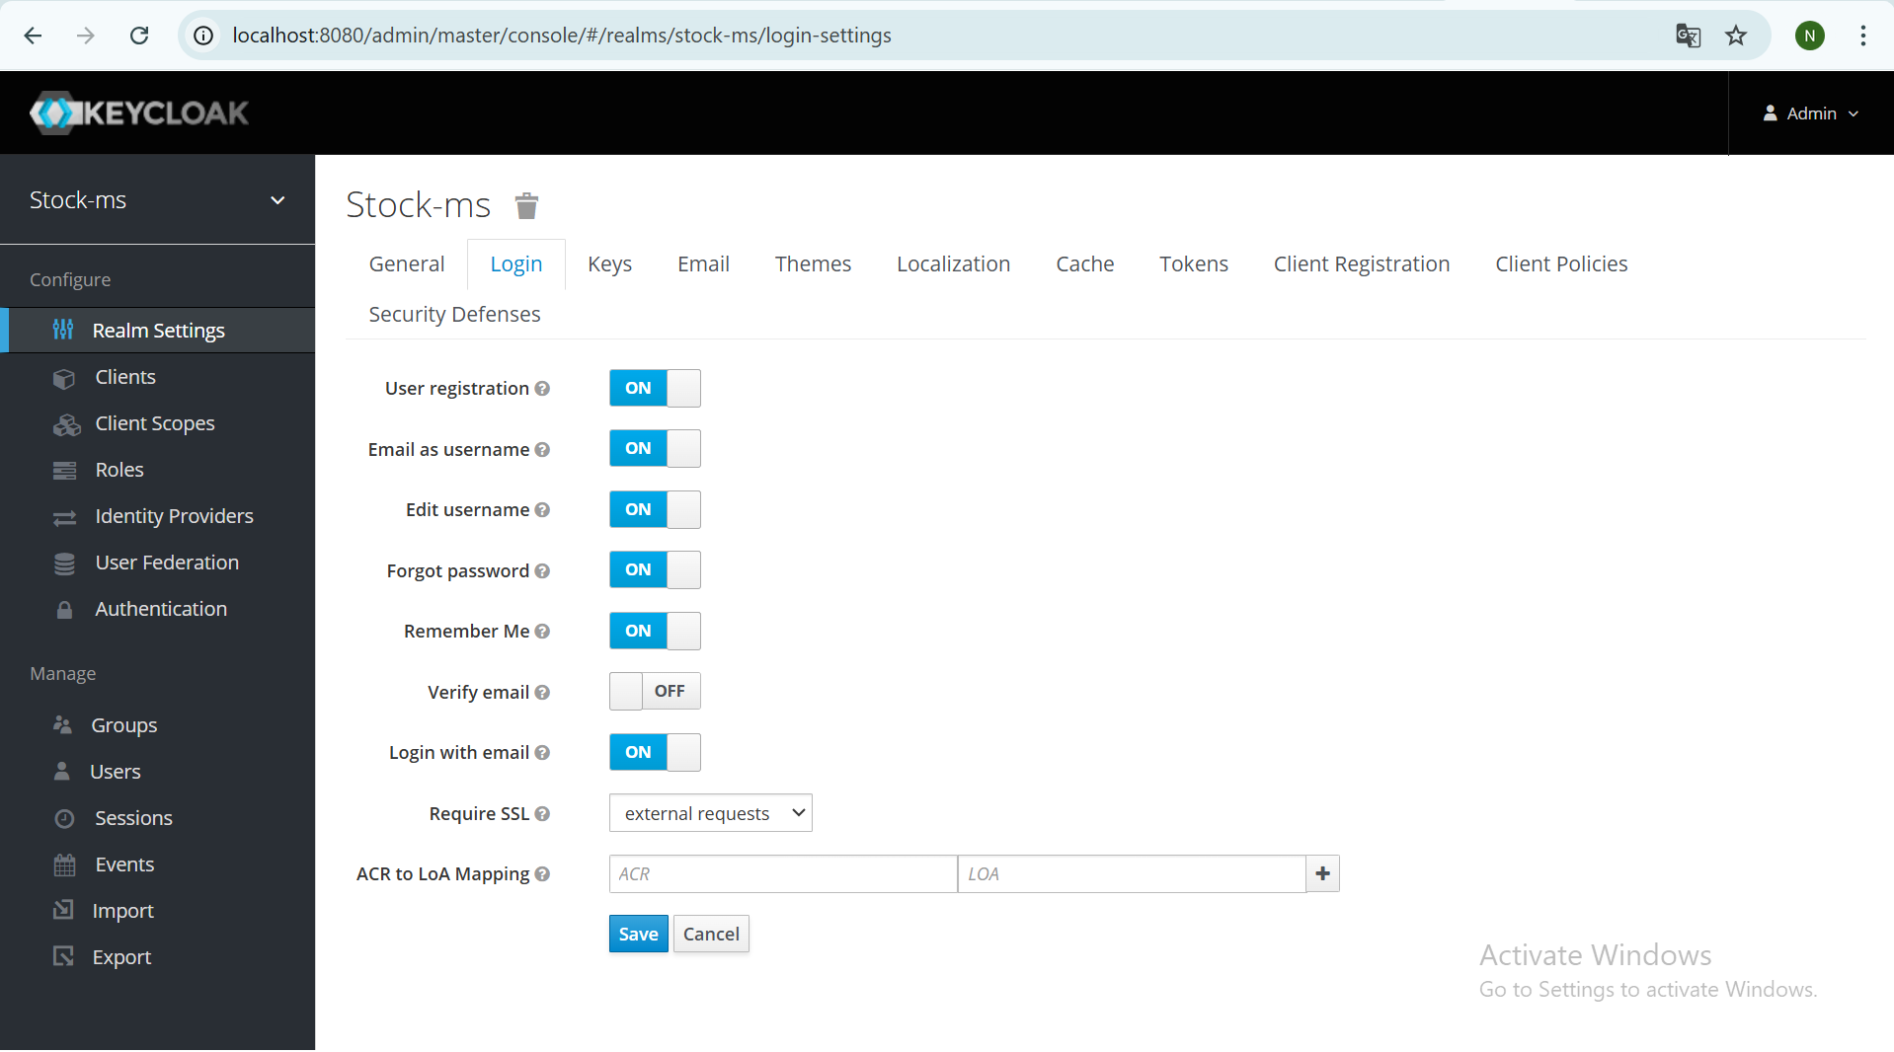

Client

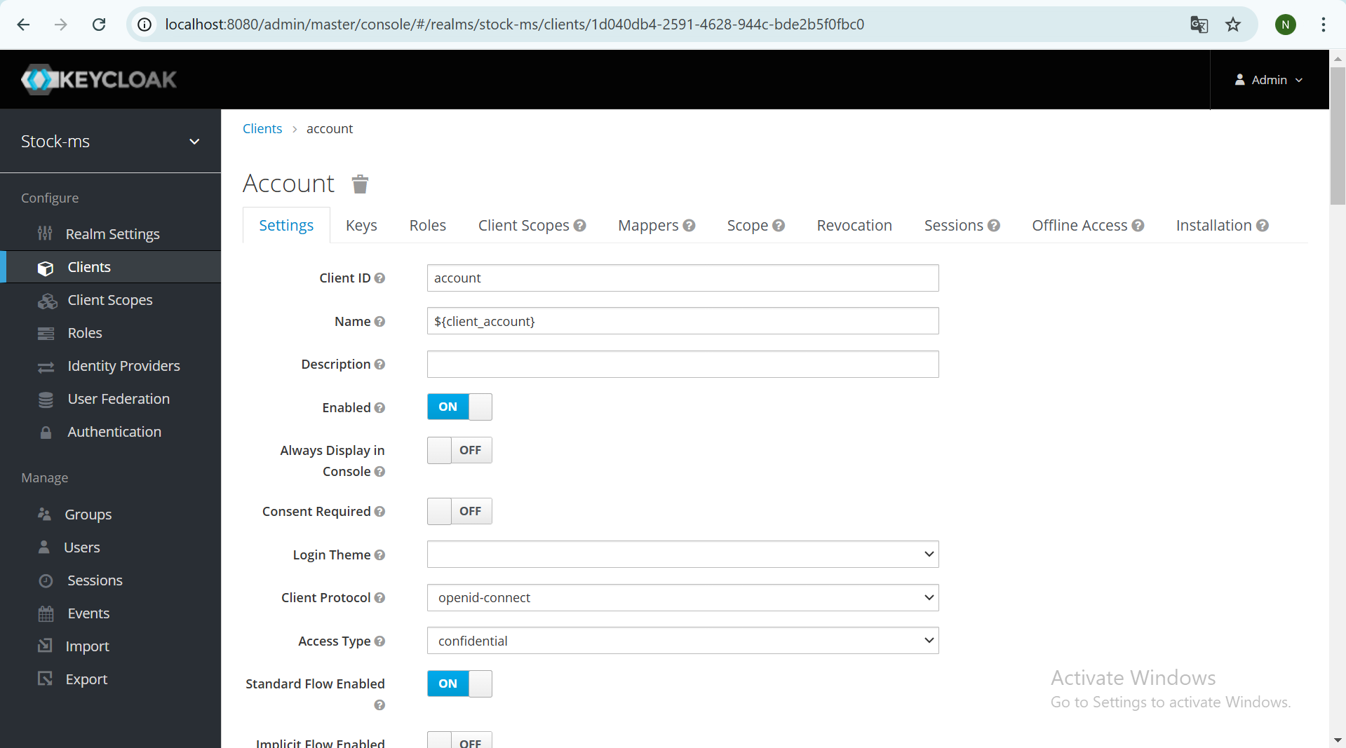

Creation User

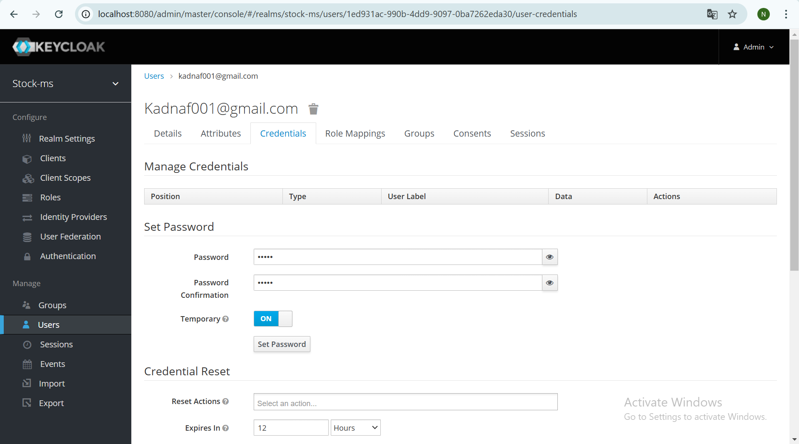

OpenID Endpoint Configuration

issuer

http://localhost:8080/realms/stock-ms

account-service

http://localhost:8080/realms/stock-ms/account

Signing in

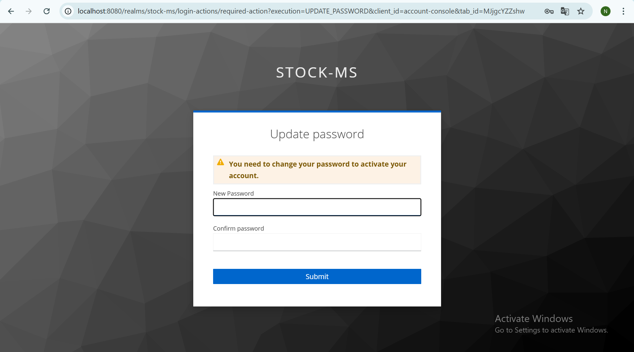

Utilisation de keycloak dans postman

Nous devons faire quelques configurations sur postman :

authorization_endpoint : http://localhost:8080/realms/stock-ms/protocol/openid-connect/auth

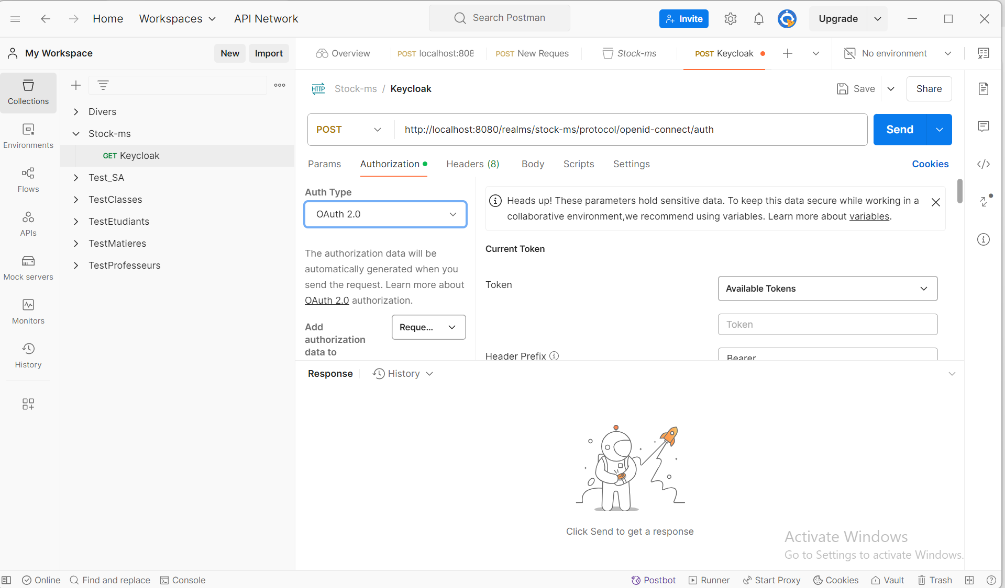

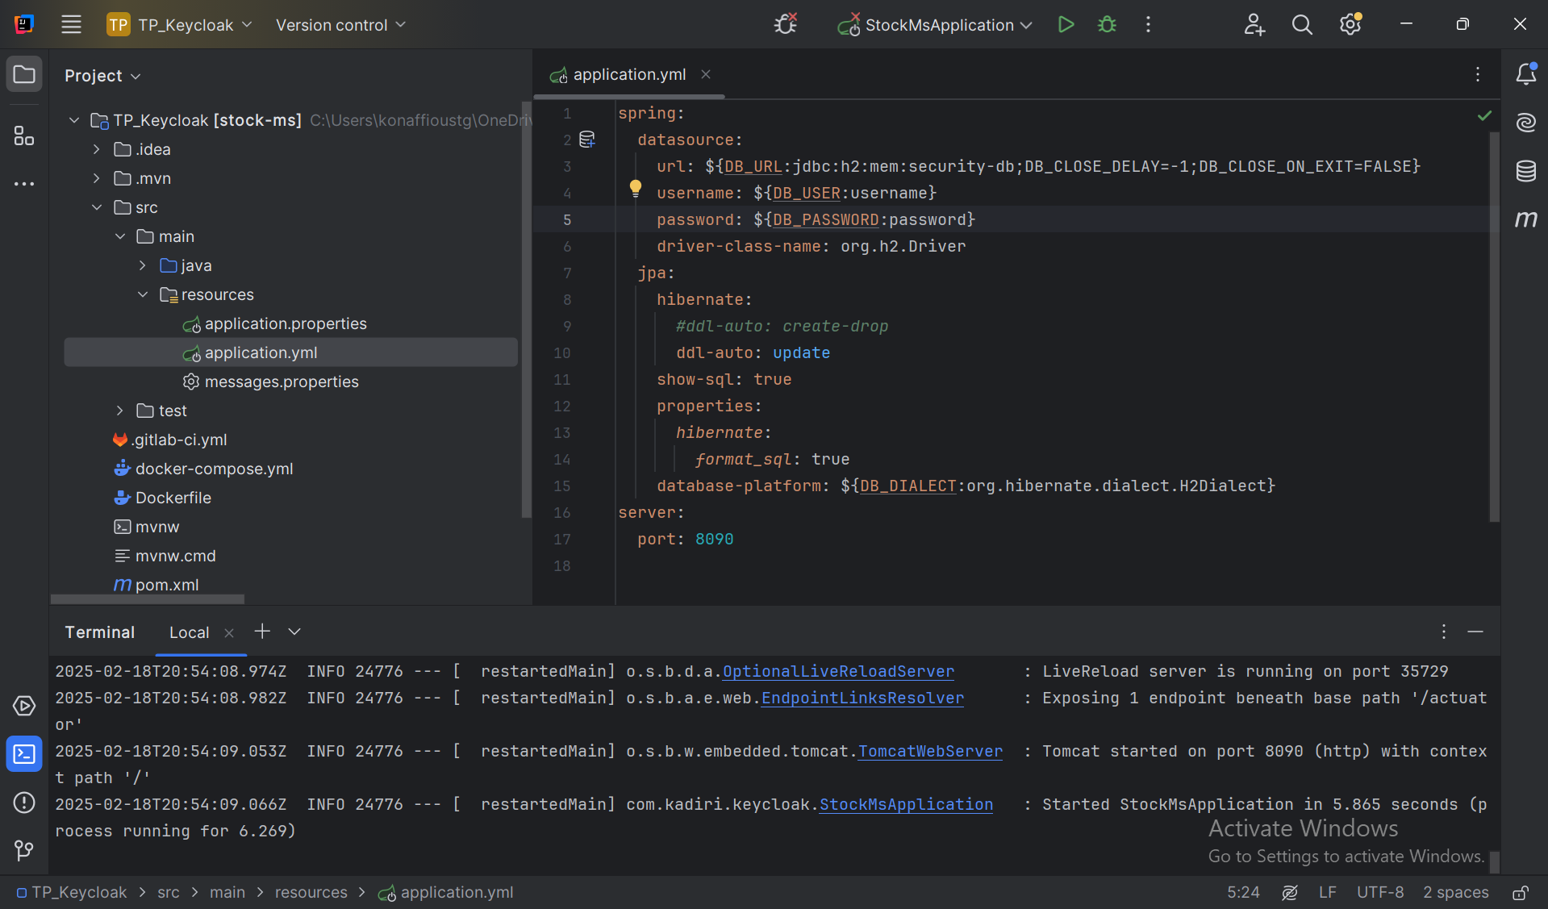

"authorization_endpoint": "http://localhost:8080/realms/stock-ms/protocol/openid-connect/auth",

"token_endpoint": "http://localhost:8080/realms/stock-ms/protocol/openid-connect/token",

Vous pouvez l’utiliser pour vos requetes

Test des end point et visualisation des données



